Type of manuscript

Mobile Based Home Automation System Using IoT and Prediction Algorithm

#1Siddharth Lodha, #2Sapna Tiwari, #3Rajashri Patil, #4Kedarnath Shinde

Under guidance of Prof. E. Jayanthi

1siddharthlodha42@gmail.com

2sapnatiwari978@gmail.com

3 rjpatil9548@gmail.com

4kedarnaths782@gmail.com

Department of Computer Engineering, Savitribai Phule Pune University,

Sinhgad College of Engineering, ,Vadgaon BK, Pune – 41.

|  |  |
| --- | --- |
| ABSTRACT | ARTICLE INFO |
| Internet of Things(IoT) includes a variety of heterogenous systems, and has become one of the most popular technology paradigms which has a plethora of applications in our day to day lives. One of the popular applications is home automation. Home automation has become a buzzword today. Many countries are making attempts to make their cities smart and more efficient to combat the problem of increasing population and depleting resources through home automation. This paper focuses on how IoT paradigm can be used for connecting and controlling various home appliances remotely and how a prediction alogorithm can be used to predict user activities.  Keywords— IoT, home automation |  |

1. **Introduction**

Internet of Things (IoT) is a communication paradigm in which everyday objects such home appliances, vehicles, etc are connected to the internet and can communicate with one another. All these things are uniquely addressable. By connecting these everyday things to internet, IoT promotes the development of a wide variety of applications that make use of the huge amount of data produced by these objects. IoT has become a pervasive technology encompassing every possible domain , some of which include industrial control, healthcare, logistics, retail, home automation, smart city and others. According to CISCO, it is estimated that 50 Billion devices would be connected to the Internet by 2020

There are 6 elements in IoT, i.e., identification, sensing, communication technologies, computation, services and semantic. Identification performs the matching between services and demand. Sensing involves gathering data from connected objects and sending it to data warehouse. Among the many IoT applications, home automation is increasingly becoming popular, a smartphone based home automation system allows user to remotely control home appliances using their android smart phones. Different types of sensors such as temperature sensor, humidity sensor, etc can be used for collecting this data. Communication technologies such as Wi-Fi, Bluetooth, IEEE 802.15.4, etc are used for connecting various objects. Computation is performed by microprocessors or microcontrollers using hardware platforms(Arduino, Raspberry Pi) and software platforms(LiteOS, TinyOS).Services can be classified as identity- related services, information-aggregation services, collaborative-aware services and ubiquitous services[1].

The application of IoT to home automation resulting in the manifestation of smart homes is of particular interest considering the huge number of benefits and improvements it brings about. Smart homes play an important part in realising smart cities. The word “smart” in smart homes and smart cities signifies the use of information and communication technologies (ICT) and internet of things (IoT) to automate and control various appliances. With the drastic improvement in cloud computing and data analytics, the data collected from smart automated homes can be better processed and analysed. As home automation systems become more widespread, they must be able to predict future events and then adapt to these future events. Such a prediction goes a long way in making home automation systems autonomous and enhancing user comfort.

1. **Literature Review**

In year 2015, an IEEE paper on- “ Mobile based Horne Automation using Internet of Things(IoT) ” authored by Kumar Mandula, Ramu Parupalli, CH.A.S.Murty, E.Magesh, Rutul Lunagariya was published. In this paper, a unique architecture for loT based home automation using low cost android phones and Arduino board in Indian context is proposed. Using an Android smart phone application, various electrical appliances are controlled.

In order to meet growing needs of the people, two prototype models namely 1. Home Automation using Bluetooth and 2. Home Automation using Ethernet are presented in this paper. In the former case connectivity between Arduino and smart phone is established using Bluetooth, one of the short range wireless communication technologies that can be used for communication in an indoor environment. The Bluetooth based solution cannot be used from a distant location, as it uses short-range wireless communication technology, which can work up to lO-20 meters only. This application can only be used by a person to control and manage appliances in an indoor environment. The main drawback of Bluetooth based horne automation can be overcome using Ethernet technology. An Ethernet module is used for connecting Arduino board from any part of the world [2].

In 2012, an IEEE paper on “An improved position prediction algorithm based on Active LeZi in Smart Home” authored by Hongqing Fang and Jinjin Ruan was published. In this paper, an improved Time varying LeZi algorithm (TALZ) is proposed, which is based on Active LeZi algorithm. Compared to some predict algorithms mentioned above, TALZ not only inherits the perfect advantage of Active LeZi algorithm, but also has a corresponding improvement in the position prediction accuracy. The periodicity in human daily habits is used to predict the behaviour of an inhabitant and position of an inhabitant in smart home. ALZ establishes a large tree with all sample information, however, TALZ divides the large tree into 24 small trees, since there are 24 hours in a day. Time-varying LeZi model has the best prediction accuracy [3].

In 2007, an IEEE article on “Online Sequential Prediction via Incremental Parsing: The Active LeZi Algorithm” authored by Karthik Gopalratnam and Diane J. Cook was published. In this article the authors have investigated the potential of constructing a prediction algorithm based on data compression techniques such as LZ78 and Active LeZi algorithms. The paper also considers the relative time between events, i.e. how much time will elapse between the events. The time between events often depends on the particular sequence or history of events. Given that such a dependency exists in certain sequential processes of events, the authors have used a sequential predictor such as ALZ to learn a relative time interval between events in the sequence [4].

1. **Proposed System**

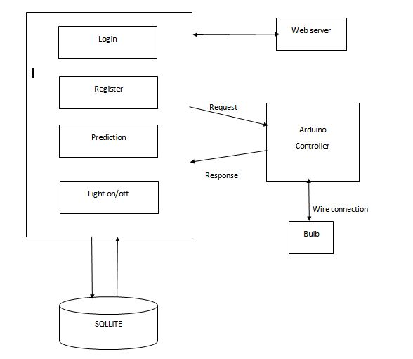

Fig.1 Block Diagram

**Modules description:**

Login

This module is used to log into the Android application.. This module also performs the essential validation checks on the email address and password entered into by the user and uses the encryption algorithm known as

Server

Manages the database through request sent or received. Authentication process is done through server. The server used in this system will be Apache Tomcat server.

Database (SQLite)

The information such as the timestamp of performing any action, the appliance on which the action is performed and the action (ON/OFF) which is performed is stored in every tuple of the table.

Register

The user first signs up by providing the email address and password and then the same credentials are used for login. These credentials are stored in the database.

Prediction

This module houses the prediction algorithm, which is used to formulate an approximate prediction of the next event in terms of the devices, which will be turned ON/OFF. The prediction manifests itself in the form of an app notification.

Arduino Controller

Arduino is a open source platform that is used for prototyping the hardware and software. Arduino can be programmed to receive keyboard input or sensor data and control various electrical appliances connected to output peripherals

1. **Conclusion**

This proposed system presents the overall design of Home Automation System with low cost and wireless system. This system is designed to assist and provide support in order to fulfil the needs of elderly and disabled in home. In addition, the smart home concept in the system improves the standard of living at home. Focus of this system has been to control the household equipment’s like light, fan, AC, etc. This System uses a sequential prediction algorithm, which observes sequence of events to predict the next event in smart environment. This prediction is useful in many scenarios for e.g., predicting inhabitant activities provides a basis for automating interaction with environment and improves the inhabitants comfort. This is achieved using Arduino board and android mobile application.

**ACKNOWLEDGEMENT**

Every work is source, which requires support from many people and areas. It gives us proud privilege to complete the project “Mobile Based Home Automation System Using IoT and Prediction Algorithm” under valuable guidance and encouragement of my guide Prof. E. Jayanthi. We are extremely grateful to our respected H.O.D. (Computer Department.) Prof. M. P. Wankhade for providing all facilities and every help for smooth progress of the project. We would like to thank all the staff members of Computer Engineering Department for timely help and inspiration for completion of the project. At last, we would like to thank all the unseen authors of various articles on the Internet, for helping us become aware of the research currently ongoing in this field.

**REFRENCES**

[1] Chunsheng Zhu,(Student Member, IEEE), Victor C.M. Leung, (Fellow, IEEE),LEI SHU2, (Member, IEEE), Edith C.-H. NGAI3, (Senior Member, IEEE), Green Internet of Things for Smart World, IEEE access, SPECIAL SECTION ON CHALLENGES FOR SMART WORLDS.

[2] Kumar Mandula, Ramu Parupalli, CH.A.S.Murty, E.Magesh, Rutul Lunagariya,” Mobile based Horne Automation using Internet of Things(IoT)”, 2015, IEEE

[3] Hongqing Fang, and Jinjin Ruan, “An improved position prediction algorithm based on Active LeZi in Smart Home”, 2012,IEEE.

[4] Karthik Gopalratnam , Diane J. Cook, “Online Sequential Prediction via Incremental Parsing: The Active LeZi Algorithm”, 2007, IEEE